‘Make Your Own Present’ Workshop at Peace Of Glass’ Studio
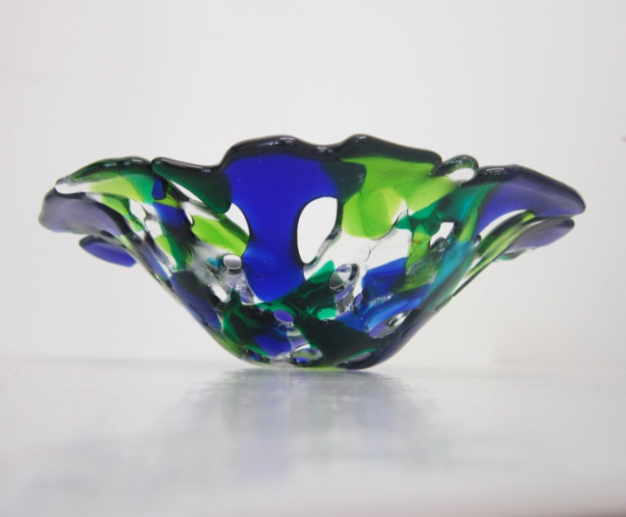

Create your own piece of glass art guided by Contemporary Glass Artist Roberta De Caro.
The cost for one-to-one is £80.00, £20.00 for one additional person.
To book simply email me (Roberta) at robertadecaro@peaceofglass.co.uk with subject line ‘ WORKSHOP enquiry’or call me on 07951391987.
- Available Monday to Friday 10.30 am till 12 pm*or evenings and weekends by appointment**;
- No previous experience necessary;
- Cost of materials included;
- Fun and relaxed environment;
During the workshop you will be introduced to the basics of the beautiful art of glass fusion.
You will practice cutting glass and assembling it to create your own piece of glass art, ready to fire in the kiln.
WARNING: Working with glass is HIGHLY ADDICTIVE ;)

Peace Of Glass by Roberta de Caro 07951 391987
Unit 9, 11 Sancroft Street, London SE11 5UG
info@peaceofglass.co.uk
www.peaceofglass.co.uk
**extra fee of £15.00 applies.

